* 1. Design high-fidelity prototype
* I using Axure

4.2.0 Home: it's the navigation button inside the app

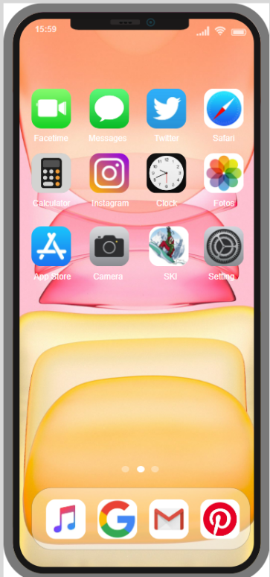

*Fig 37 : Home*

* + 1. Welcome: in the screen there is a start button the user can click to be able to enter the login section in the app

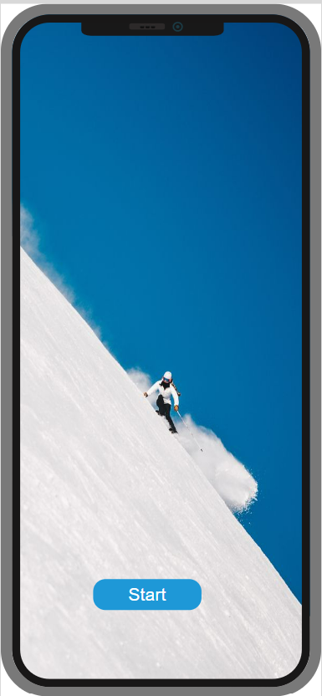

*Fig 38: Welcome*

* + 1. Login: this is the login page when you enter the correct information it will display a message that you have successfully logged in and move to the next page

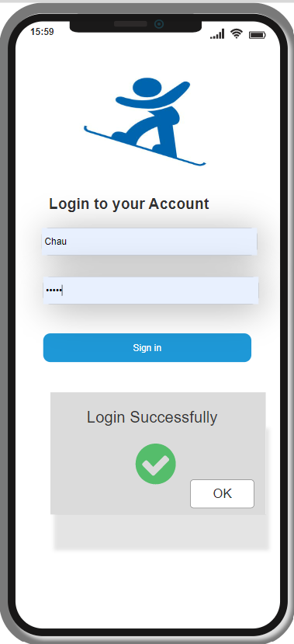

*Fig 39: Login*

* + 1. Home Page: this is the home page of the app that includes ski pictures and functions with three buttons: locate, history, start skiing users just need to click if they want.

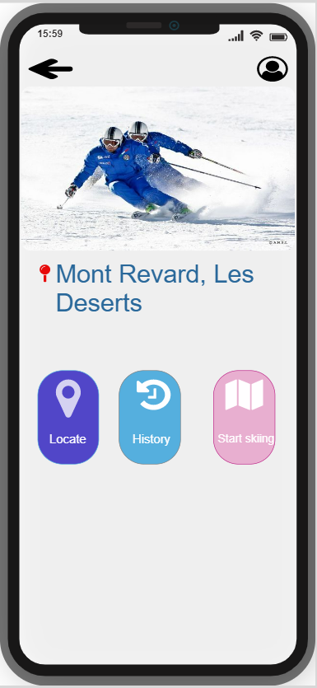

*Fig 40: Home Page*

* + 1. Locate: if you want to navigate on locate button it will show your current location and restaurants and cafes near you. You can click on the restaurant icons, it will be a fork and a spoon, and the cafe will be a cup icon for hot coffee.

*Fig 41: Locate*

* + 1. Search : There is also a search button on the top of the map when clicking on it will link to the search page as said on the site map eg: you want to go to a cafe called Aux Folies , you just need to click on the letter "a" " it will suggest you a name Aux Folies you just click on the selected name it will navigate you to the information page of the cafe you have chosen

*Fig 42 : Search*

* + 1. Aux Folies: In the information board of the Aux Folies , there is a red map icon, it will guide you to that shop and display customer reviews for more peace of mind.

*Fig 43 : Aux Folies*

* + 1. Aux Folies Inf: The information board about the shop is named Aux Folies Inf when you selected it in the search

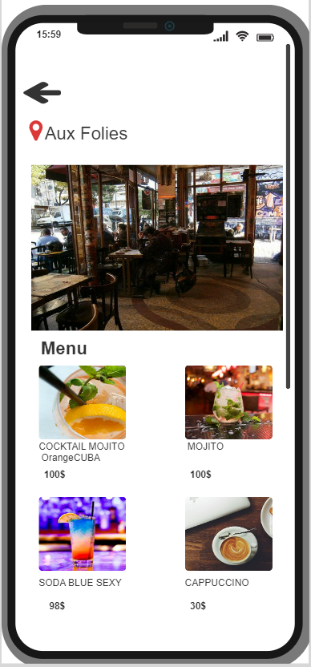

*Fig 44 : Aux FoliesInf*

* + 1. Cafe de Flore: In the information board of the Cafe de Flore , there is a red map icon, it will guide you to that shop and display customer reviews for more peace of mind.

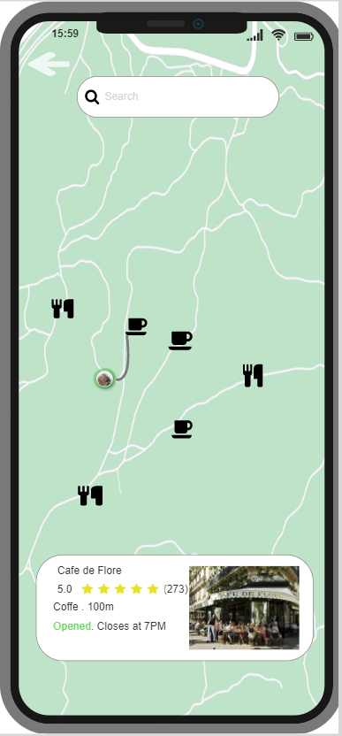

*Fig 45 : Cafe de Flore*

* + 1. Cafe de Flore Inf: The information board about the shop is named Cafe de Flore when you selected it in the search

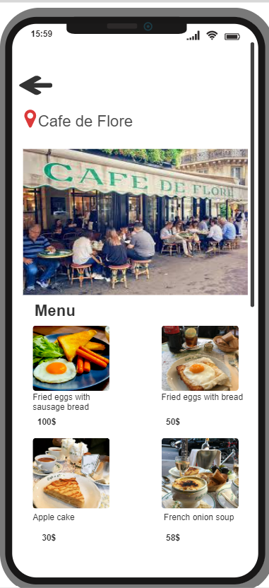

*Fig 46 : Cafe de Flore Info*

* + 1. Au Petit Fer a Cheval: In the information board of the Au Petit Fer a Cheval , there is a red map icon, it will guide you to that shop and display customer reviews for more peace of mind

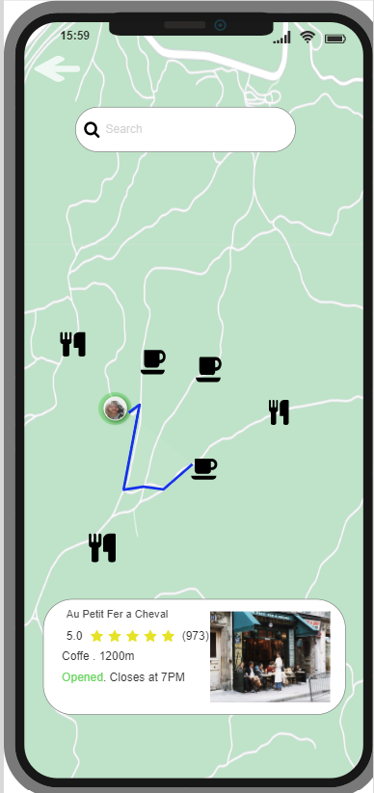

*Fig 47 : Au Petit Fer a Cheval*

* + 1. Au Petit Fer a Cheval Inf: The information board about the shop is named Au Petit Fer a Cheval when you selected it in the search

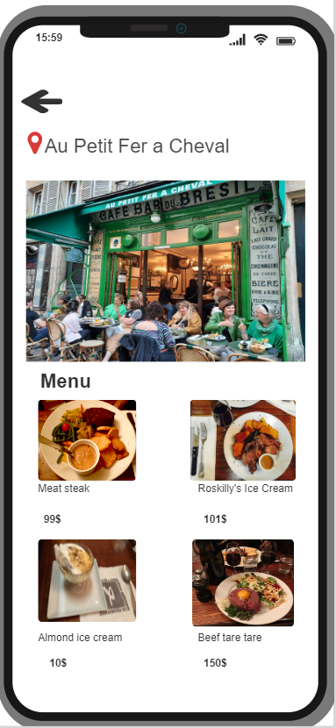

*Fig 48 : Au Petit Fer a Cheval Inf*

* + 1. Il Etait Un Square: In the information board of the Il Etait Un Square , there is a red map icon, it will guide you to that shop and display customer reviews for more peace of mind.

*Fig 49 : Il Etait Un Square*

* + 1. Il Etait Un Square Inf: The information board about the shop is named Il Etait Un Square when you selected it in the search

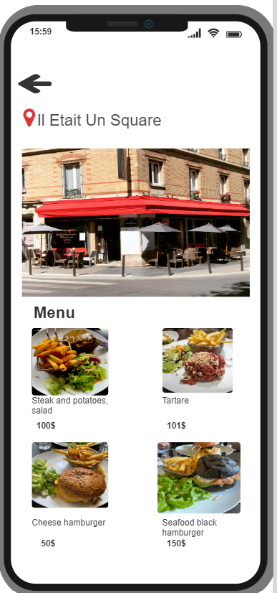

*Fig 50 : Il Etait Un Square Inf*

* + 1. Cavale: In the information board of the Cavale , there is a red map icon, it will guide you to that shop and display customer reviews for more peace of mind.

*Fig 51 : Cavale*

* + 1. Cavale Inf: The information board about the shop is named Cavale when you selected it in the search

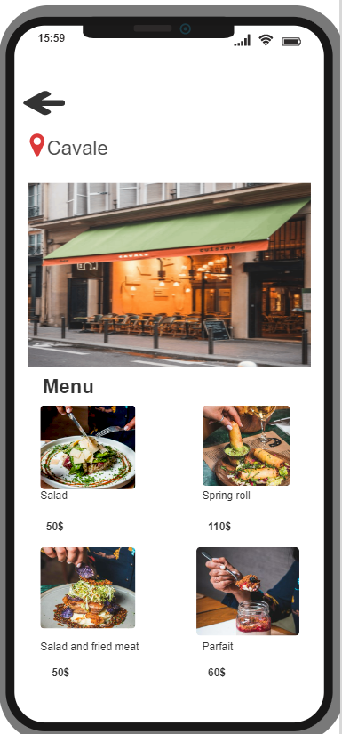

*Fig 52 : Cavale Inf*

* + 1. Bistrot Instinct: In the information board of the Bistrot Instinct , there is a red map icon, it will guide you to that shop and display customer reviews for more peace of mind.

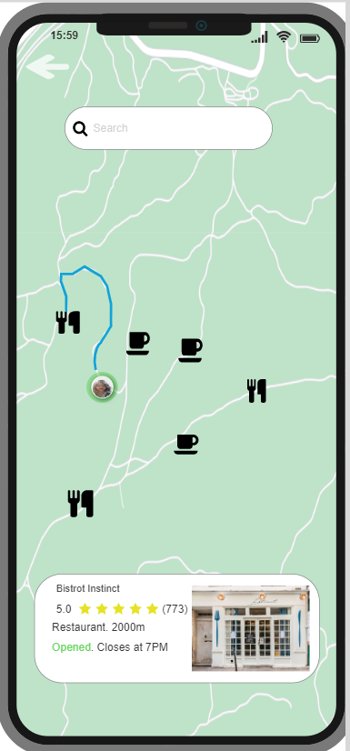

*Fig 53 : Bistrot Instinct*

* + 1. Bistrot Instinct Inf: The information board about the shop is named Bistrot Instinct when you selected it in the search

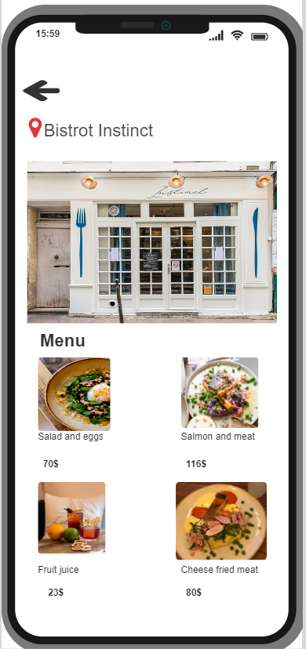

*Fig 54 : Bistrot Instinct Inf*

* + 1. History S: Information about the day of skiing and it will record the information if you enter the column marked with "S" for the week it will display information about km, calories, mountain skied, temperature, ski time what time?

*Fig 55 : History S*

* + 1. History M: Information about the day of skiing and it will record the information if you enter the column marked with "M" for the week it will display information about km, calories, mountain skied, temperature, ski time what time?

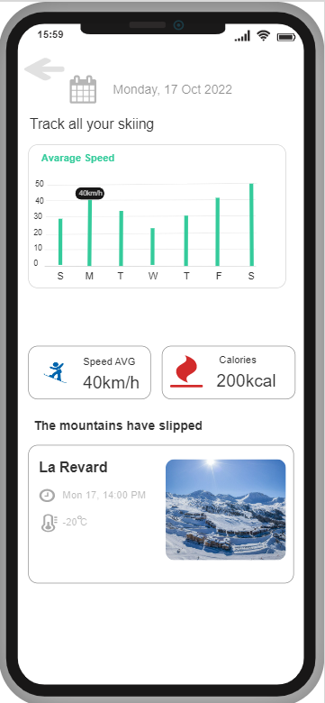

*Fig 56 : History M*

* + 1. History T: Information about the day of skiing and it will record the information if you enter the column marked with "T" for the week it will display information about km, calories, mountain skied, temperature, ski time what time?

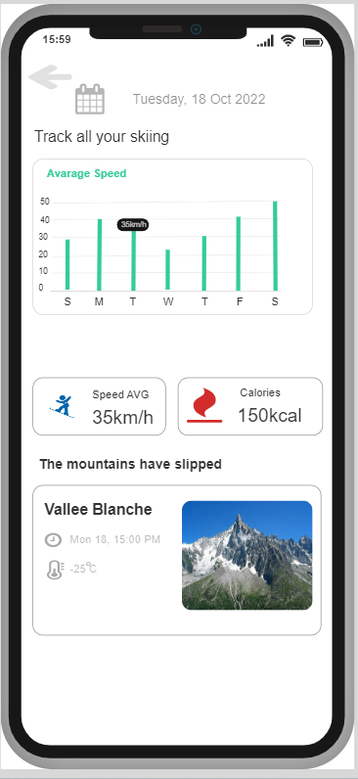

*Fig 57 : History T*

* + 1. History : Information about the day of skiing and it will record the information if you enter the column marked with "W" for the week it will display information about km, calories, mountain skied, temperature, ski time what time?

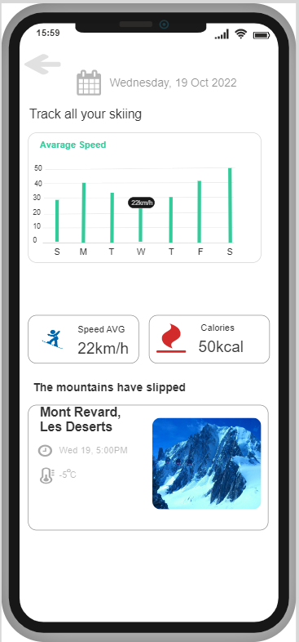

*Fig 57 : History*

* + 1. History TH: Information about the day of skiing and it will record the information if you enter the column marked with "TH" for the week it will display information about km, calories, mountain skied, temperature, ski time what time?

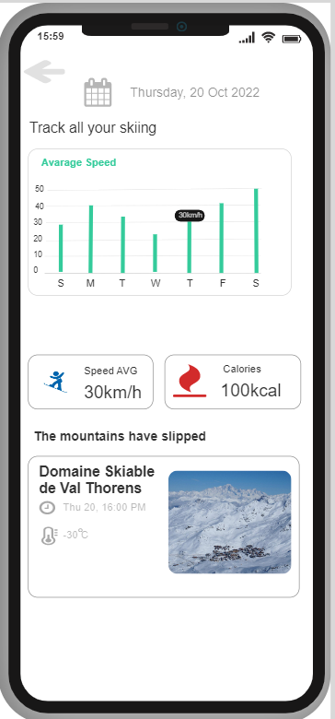

*Fig 58 : History TH*

* + 1. History F: Information about the day of skiing and it will record the information if you enter the column marked with "F" for the week it will display information about km, calories, mountain skied, temperature, ski time what time?

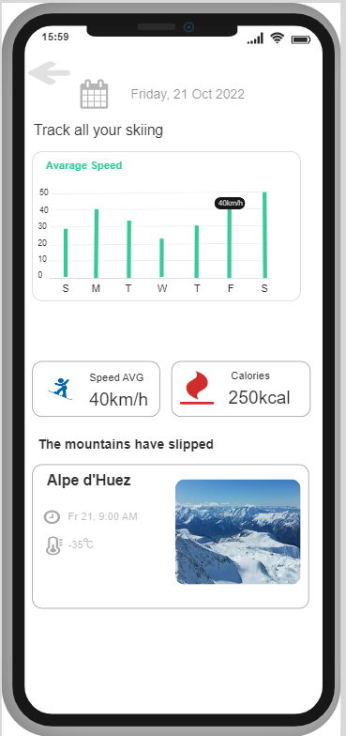

*Fig 59 : History F*

* + 1. History SA: Information about the day of skiing and it will record the information if you enter the column marked with "SA" for the week it will display information about km, calories, mountain skied, temperature, ski time what time?

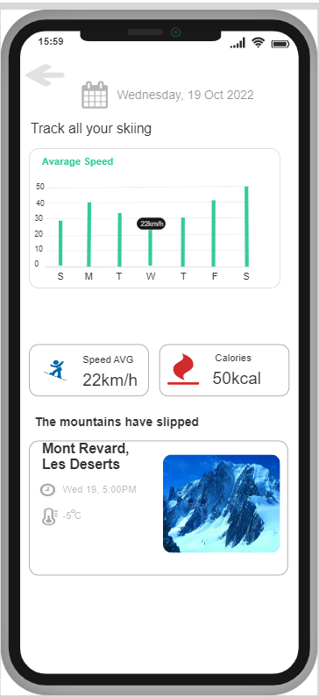

*Fig 60 : History SA*

* + 1. Start Skiing : For this site I made it so that when skiing directly it can measure the distance, average speed, calories of the skier.

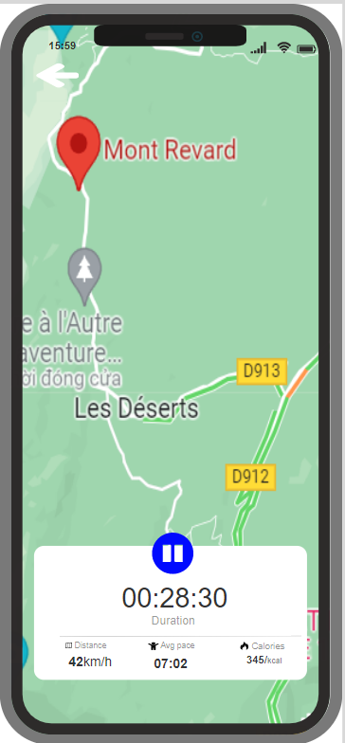

*Fig 61 : Start Skiing*

* + 1. Log Out: In the main page on the top right side of the screen, there is a human icon for logging out. When clicking on the page below that says "Log Out" it will return to the main screen and exit the application completely

*Fig 62 : Log Out*